**Clone Oracle Home**

Cloning an Oracle home involves creating a copy of the Oracle home and then configuring it for a new environment. If you are performing multiple Oracle Database installations, then you may want to use this method to create each Oracle home, because copying files from an existing Oracle Database installation takes less time than creating a new version of them. This method is also useful if the Oracle home that you are cloning has had patches applied to it. When you clone this Oracle home, the new Oracle home will have the patch updates as well.

Source Oracle home used: Development HR (uddcbdorc79:/usr/oracle/hr/product/11203)

Target Oracle home: testdba1 (uddcbdorc76: /usr/oracle/testdba1/product/11203)

Oracle home version: 11.2.0.3 standard edition

1. Logon to the source server where you want to clone Oracle Home.
2. Browse to the location where Oracle Home is and use the tar command to pack up Oracle Home.

Example: change directory > cd /usr/oracle/hr/product/11203

pack up current directory using tar > tar -cvf /tmp/11203.tar .

1. Copy tar file from source to target location by using the secure copy command.

Example: scp 11203.tar uddcbdorac76: /usr/oracle/testdba1/product/11203

1. Unpack using tar file

Example: unpack file using tar command > tar –xvf 11203.tar

1. Verify if oraInventory location is same on the target server in the oraInst.loc file. Also you may need to drop and re-create any soft links that were there.

Notice for this test, the location had to be changed in the oraInst.loc file highlighted in yellow.

Original: inventory_log=/usr/oracle/hr/prodduct/11203/oraInventory

Change to: inventory_log=/usr/oracle/testdba1/prodduct/11203/oraInventory

1. Run the OUI installer by running the following command. The location of the OUI installer can be found under $ORACLE_HOME/oui/bin directory.

Example: ./runInstaller -clone -silent -invPtrLoc "/usr/oracle/testdba1/product/11203/oraInst.loc" -noconfig ORACLE_HOME="/usr/oracle/testdba1/product/11203" ORACLE_HOME_NAME="testdba1" ORACLE_BASE="/usr/oracle" oracle_install_OSDBA=dba oracle_install_OSOPER=oinstall

**Note**: if Oracle Home already exists in the central inventory on the target server then you will need to detach Oracle Home before you can register. Here’s the command to detach Oracle Home.

./runInstaller -invPtrLoc "/usr/oracle/testdba1/product/11203/oraInst.loc" -detachHome ORACLE_HOME="/usr/oracle/testdba1/product/11203"

Here’s a screenshot when you run the OUI installation command.

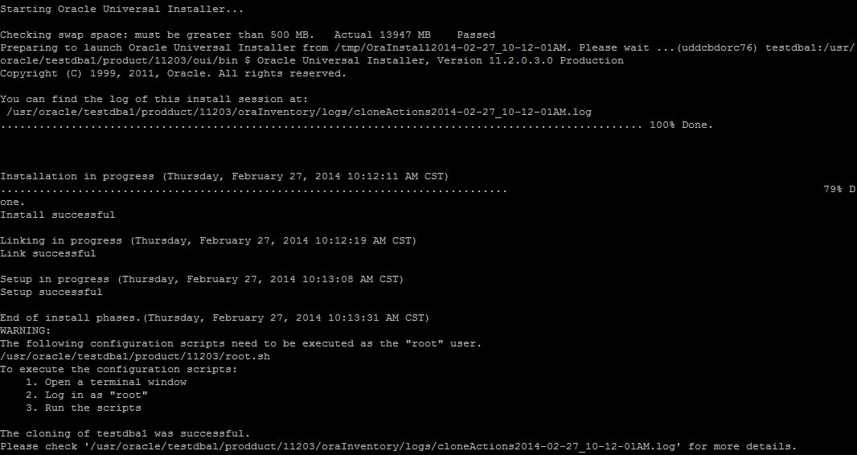

1. Once the installation completes, you will need to ask Unix admin to run the root.sh script provided at the end of the install phase. After root.sh completes, installation is complete.
2. Apply the latest Oracle patch to the new Oracle Home.

Issue encountered during installation

1. I tried using zip/unzip command, it failed to copy oraInventory directory even though it was owned by oracle user.

-Resolved by using tar command instead

1. Error #1.

SEVERE:OUI-10036:Could not create the inventory location. Ensure that you have sufficient permission to write this location, the directory names do not exceed the operating system limits, and the directory names contain valid characters, which consist of alphanumeric characters (|A|-|Z|, |a|-|z|, |0|-|9|) and the dollar sign ( $ ) or underscore ( _ ).

SEVERE:OUI-10180:Invalid Operating System group name specified.

-Resolved by providing the switch –invPtrLoc during the OUI installation.

1. Error #2.

OUI-10197:Unable to create a new Oracle Home at /usr/oracle/testdba1/product/11203. Oracle Home already exists at this location. Select another location.

SEVERE:OUI-10197:Unable to create a new Oracle Home at /usr/oracle/testdba1/product/11203. Oracle Home already exists at this location. Select another location.

1. –Resolved by detaching Oracle Home first then re-run the installation.